**Technical Documentation for Project 8: Enhance an existing project. Front End developer path**

Table of contents:

1. Project Overview
2. Code Structure
3. Bugs Encountered
4. Jasmine Tests
5. Own App Audit
6. Competitor App Audit
7. Overall comparison

**Project Overview**

Project number 8 provided by OpenClassrooms required three steps that needed to be followed. The first one was to find and fix two bugs in the code. The second one was to build tests using the Jasmine framework and the third and last one was to analyze the performance of our own app and from a competitor as well. All of those requirements will be described as in-depth in the present document you can access the Confluence version [here](https://danielaburgosfrontend.atlassian.net/l/c/ZEL51N9H).

The application provided for Project number 8 was a simple Todo list.

These are its main characteristics :

* Language used: JavaScript no additional frameworks
* App architecture: MVC pattern

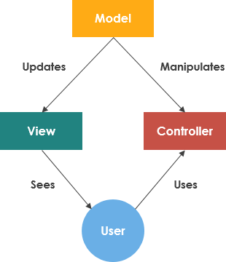

MVC refers to Model-view-controller it is a software design pattern used most commonly to build user interfaces that decouple the components of the application. The main characteristic of it remains the division of the program logic into three interconnected elements: model, view, and controller. The main goal of such an organization is that developers are able to work in parallel on different components without affecting or blocking any other.

**Code Structure**

*File Contents*

Root folder that contains two main folders:

* index.html - This is the file that loads all the JS and CSS scripts, it represents as well the main page of the application.
* package.json - The file contains all the package dependencies that the project uses.

The /js folder contains the following files:

* app.js - File that creates a new instance of all the required MVC components
* controller.js - The file that is responsible for the Controller part of the MVC pattern. This is the linking part between the model and the view together.
* helperd.js - The file contains all the help functionalities for the interactions with the DOM such as its queries.
* model.js - This file is responsible for the model part of the MVC pattern. This file contains functions that manage the data of the App.
* store.js - This file acts as the App’s fake database. The storage utilizes LocalStirahe which creates a temporary file on the user’s PC and acts as a fake persistence DB, however upon emptying the cache this database will go away.
* template.js - This file contains templates for List elements, HTML escape characters, and other DOM templates that help the App.
* view.js - this is the file that is responsible for the View part of the MVC pattern. This file contains functionality that allows us to display the data to the user, and visualize the app.

In the /node_modules folder you can find the following packages:

* jasmine-core - that enables us to write an automated test with the Jasmine Framework that tests our application.
* todomvc-app-css - that package contains the CSS styles of the app that is inherited from the TodoMVC application.

In the /test folder you can find the following 2 notable files:

* ControllerSpec.js - This file contains all the unit tests that were written for this application using the Jasmine Framework.
* SpecRummer.html - This is the front page that shows the results of the automated test were run our project. The contents of the page depending on the test written in the ControllerSpec.js file.

**Bugs encountered**

Two bugs were found and fixed during the analysis of the App.

*Bug 1*

In line 95 from /js/controller.js, there was a typo on addItem, there was an extra ’d’ on the addItem.

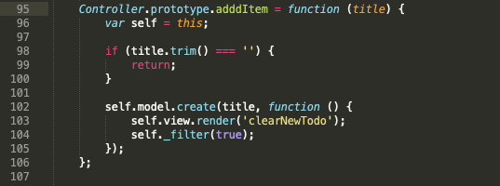

This is the final version with no error:

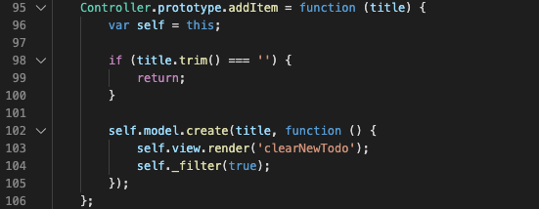

*Bug 2*

In js/store.js file, there was a potential conflict of IDs starting from line 77 in the same functionality. When generating the ID for saving new data the function hasn’t checked if the generated ID is already existing.

Here the code section affected by that issue:

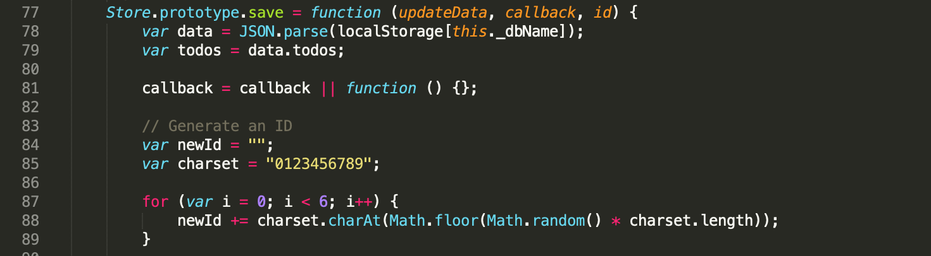

The fixed version provided below is a refactored version where we use a library uuid/v4 which provides a unique key so we don’t get a random number from the charset as before by using the math function.

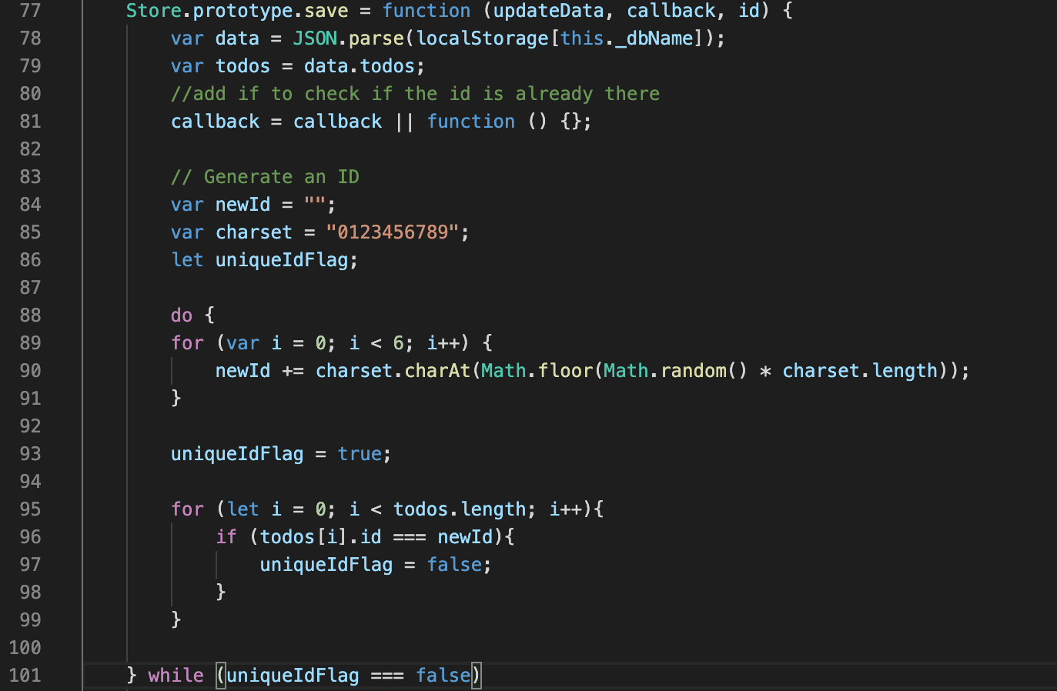

**Jasmine tests**

Thefollowing tests were solved for the current project:

* Should show entries on start-up

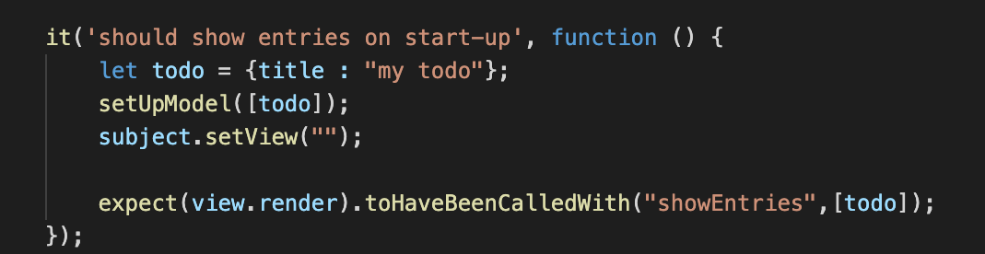

* Should show active entries

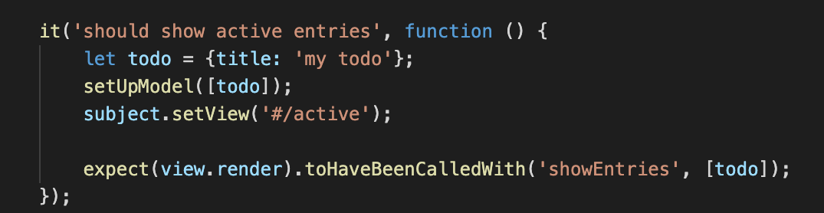

* Should show completed entries

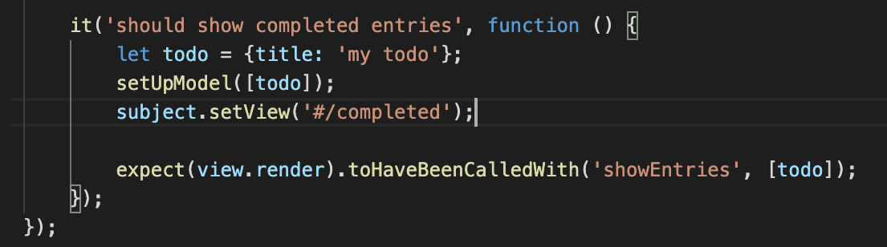

* Should show the content block when todos exists

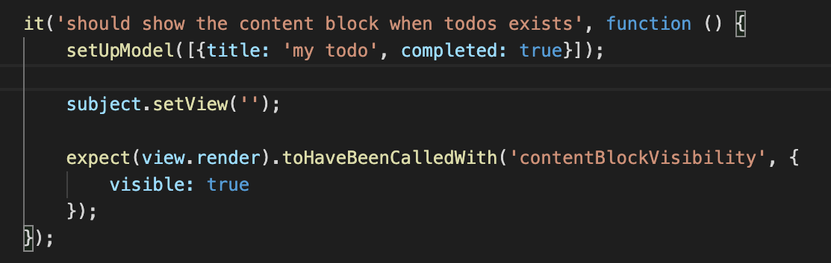

* Should highlight “All” filter by default

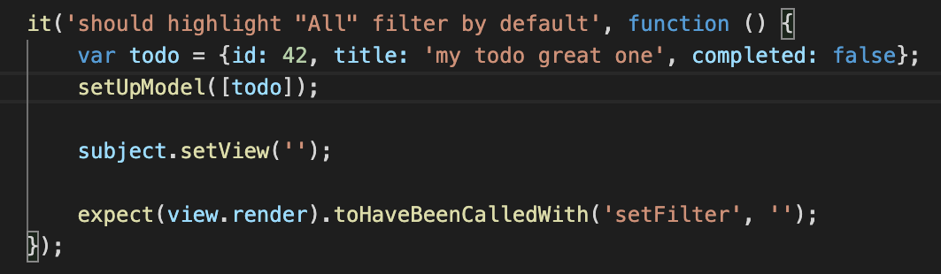

* Should toggle all todos to completed

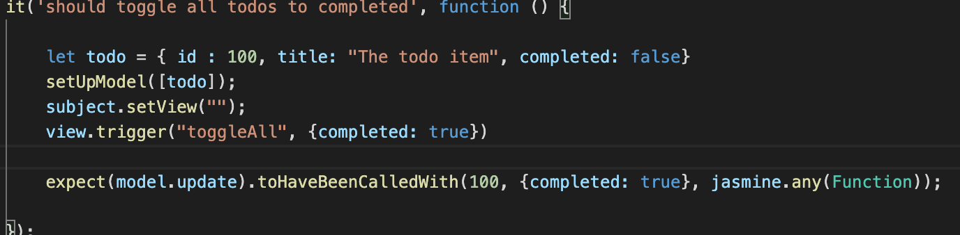

* Should update the view

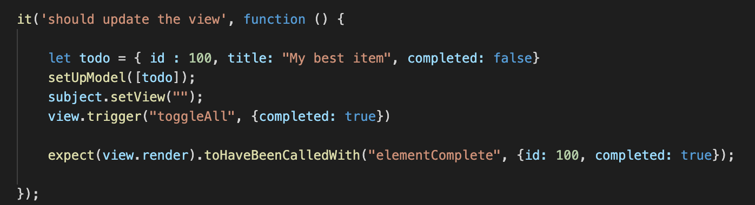

* Should add a new todo to the model

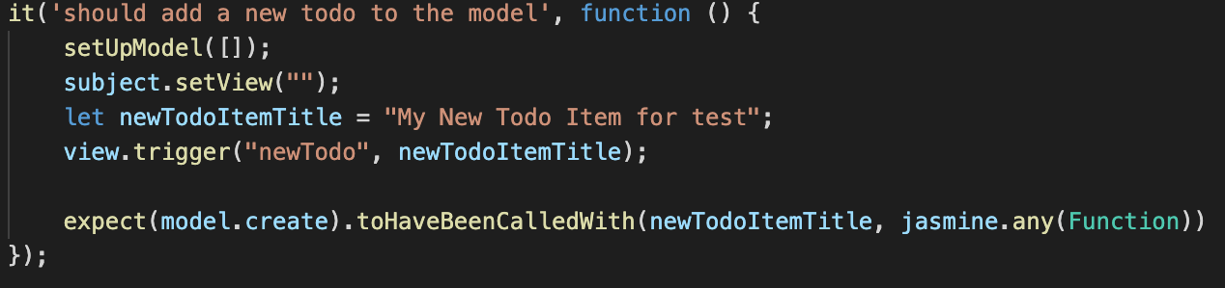

* Should remove an entry from the model

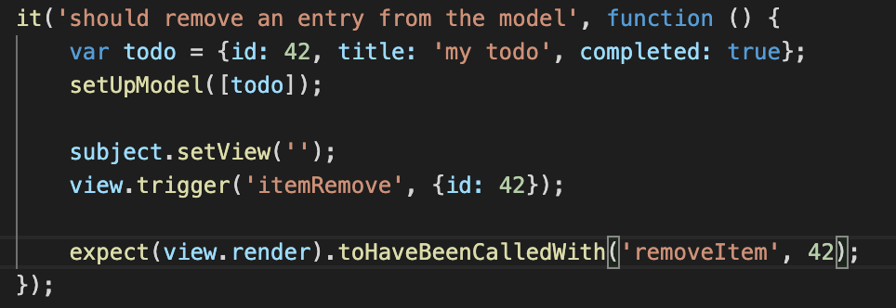

Audit performance

In order to do the competitors site performance audit we need to do the same thing for our own application to establish a base reference point.

The results between the two applications cant be directly compared and only should be used as a guidance point due to the reason that our own app was tested on several local web servers and hosting the app from there. The difference in the results were negligible in usage so only one section of results will be documented here.

Test Environment

The audit of the application and the competitor’s application was done on a Mac computer.

* The browser used in the audit on the Mac computer was Chrome Version 85.0.4183.121 (Official Build) (64-bit)

For each test, local cache has been cleaned, garbage was collected in Chrome Devtools.

Mac computer Hardware specifications:

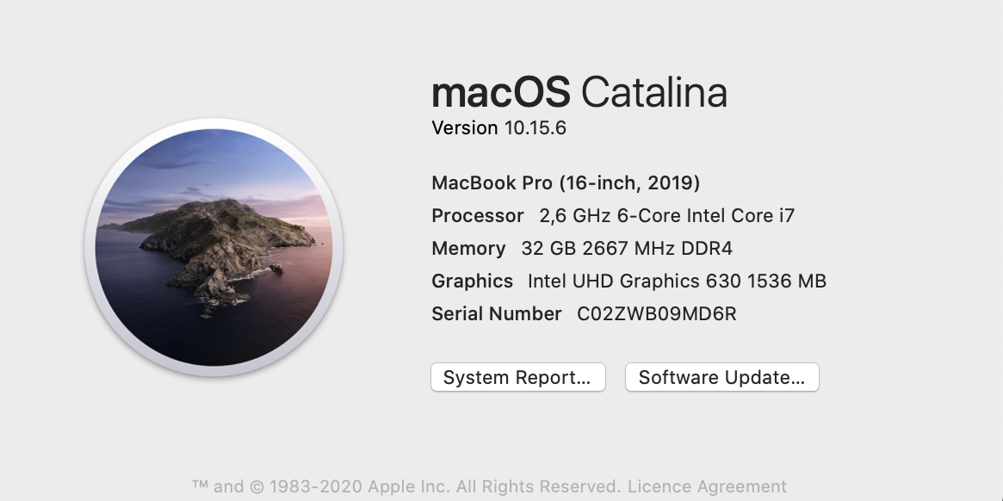

**Own App Audit**

Application Load

The application loads quite quickly due to the low content size, using pure JS, and due to the reason that it doesn’t require any load-time demanding assets such as images, videos, font libraries, etc. The app doesn't load CSS from external CDN servers either.

The load tests were also done by both simulating low 3G network speeds. Result examples will be attached as images below.

The average results on Mac:

* App size - 35.7 Kb
* Load time - 9ms
* DOMContentLoaded - 106ms
* Memory allocation- 3.54 MB

Mac results:

* Page load - Online network

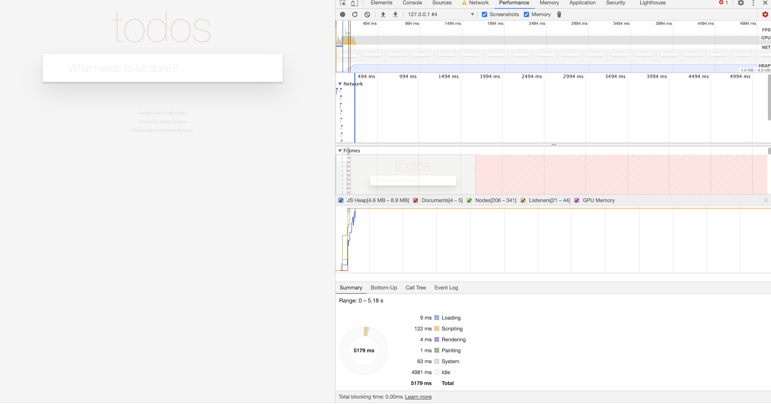

* Page Load- Slow 3G network

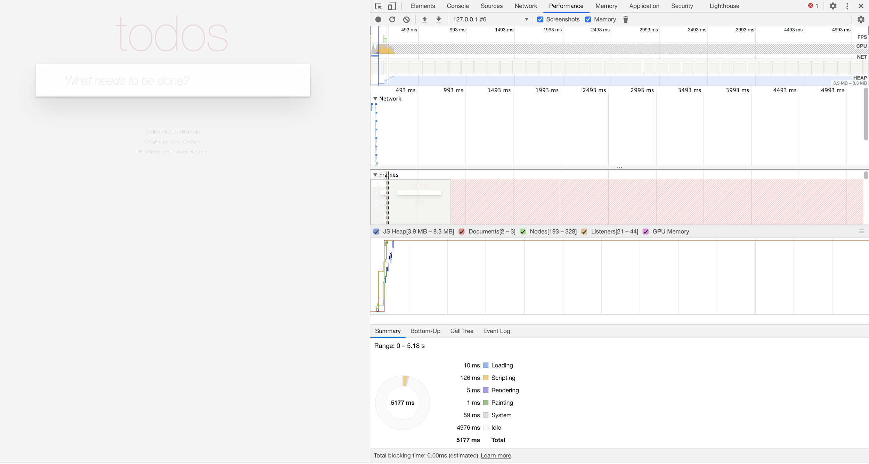

* Network - Online

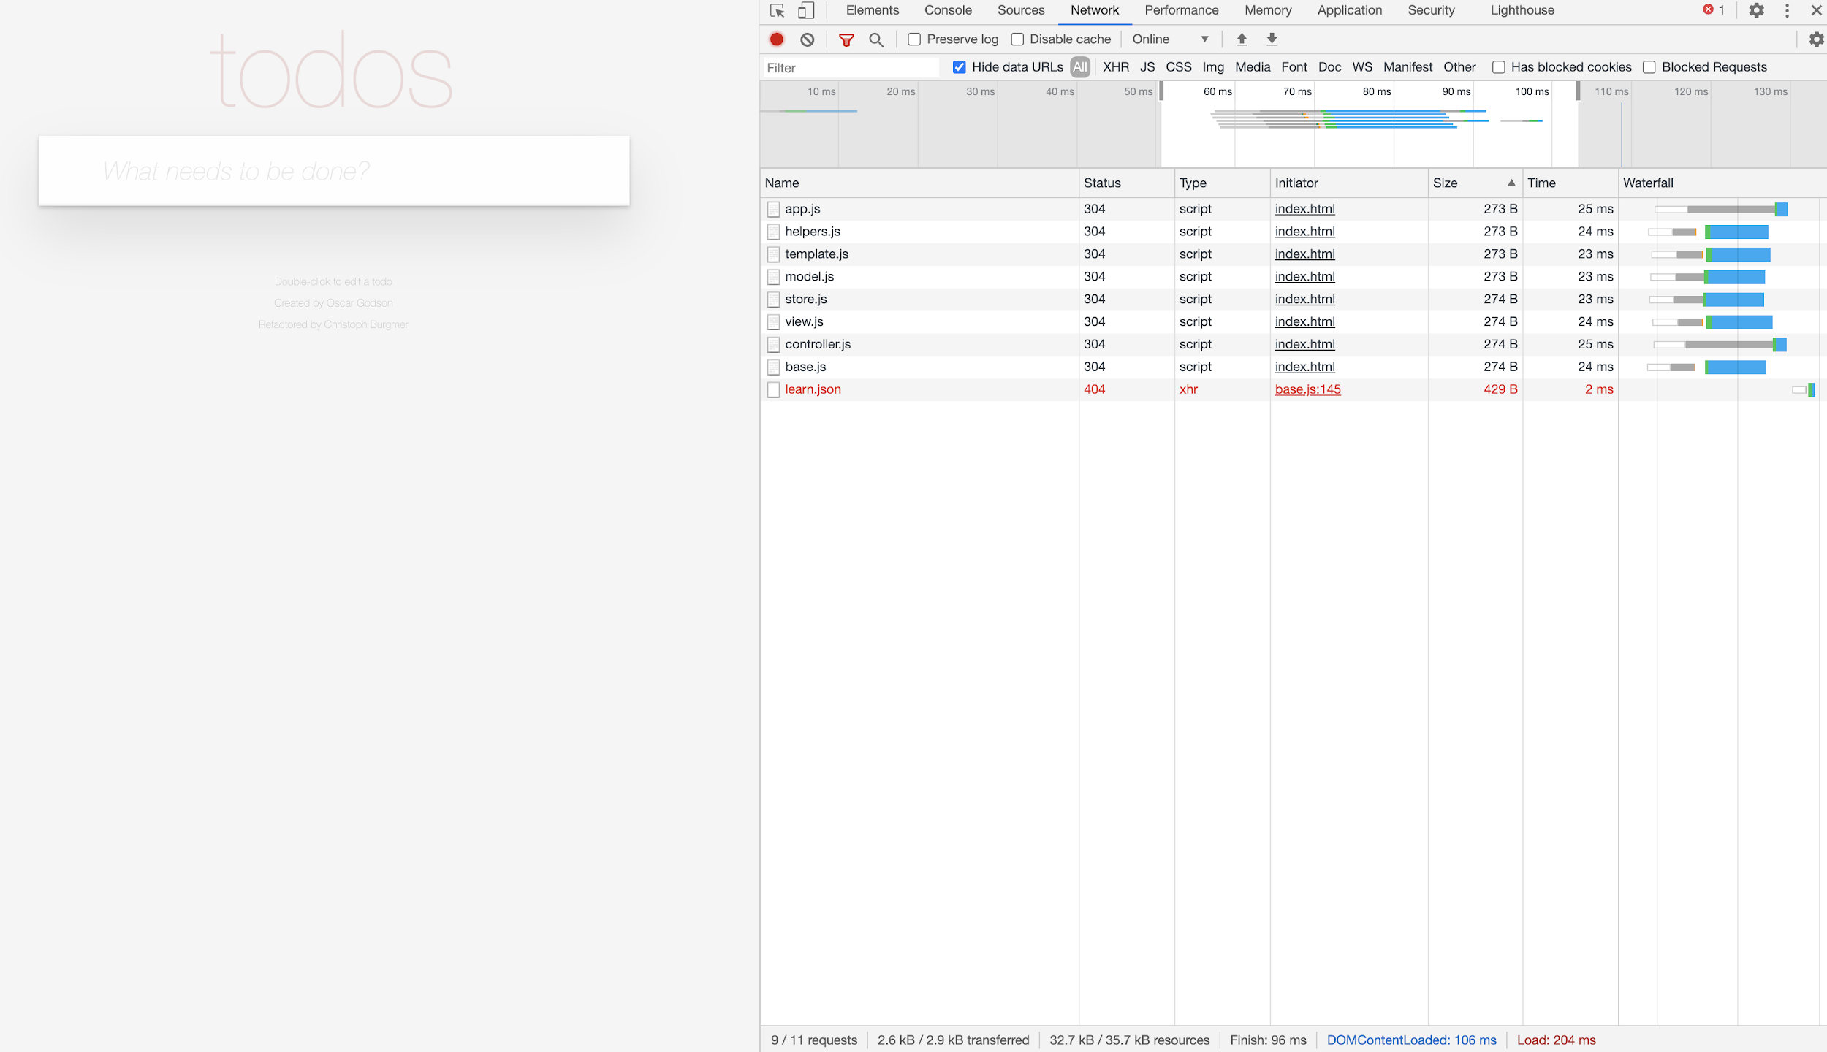

* Network - Slow 3G

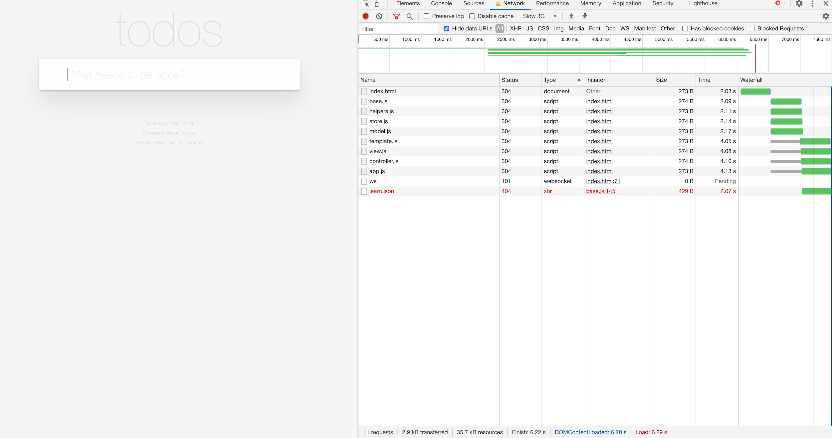

* Memory Allocation

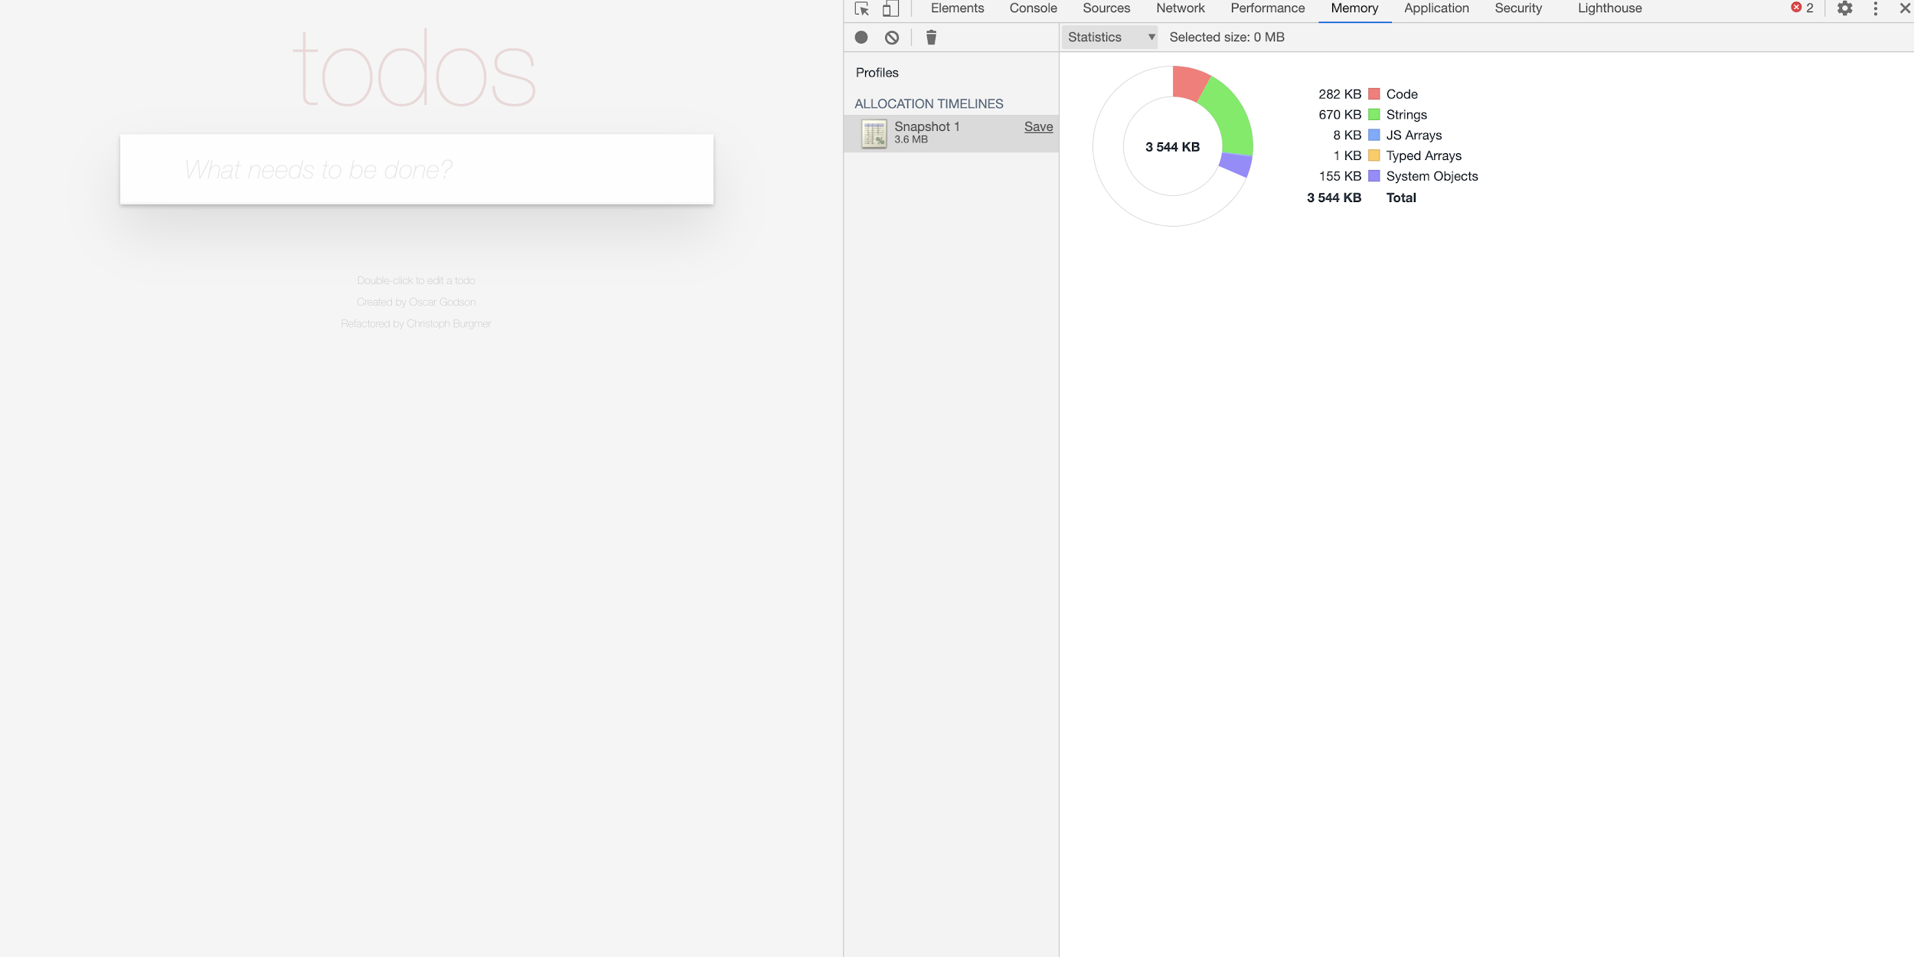

Application Use

Application general usage tests showed that the app remains to use low resources, low memory, and will continue to operate quickly.

* Application all features exercised in 32 seconds
  + Scripting- 107 ms
  + Rendering- 61 ms

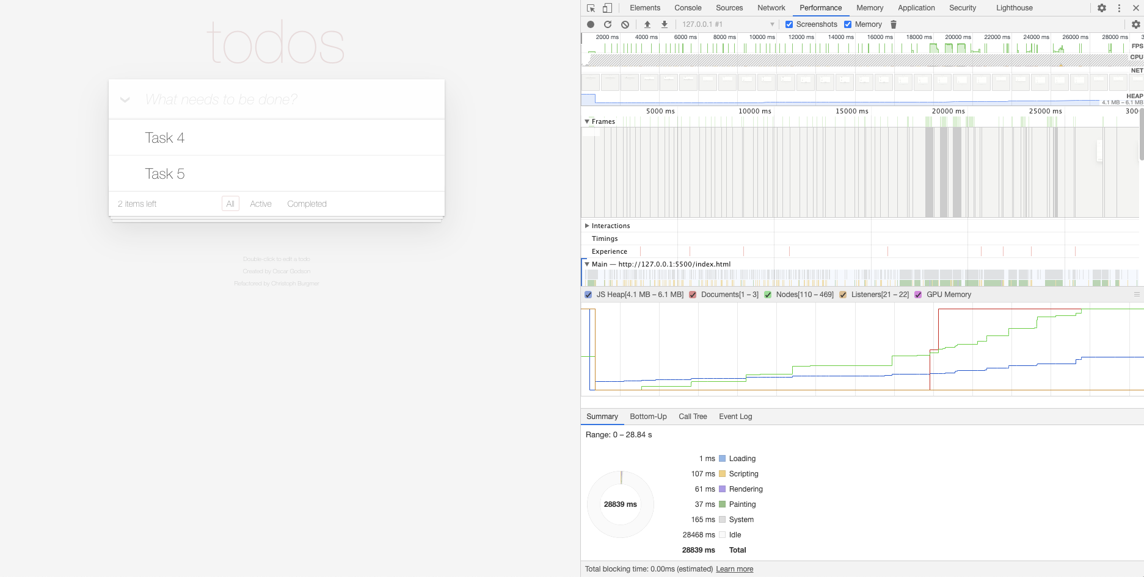

* Adding a single task
  + Scripting - 53ms
  + Rendering - 11ms

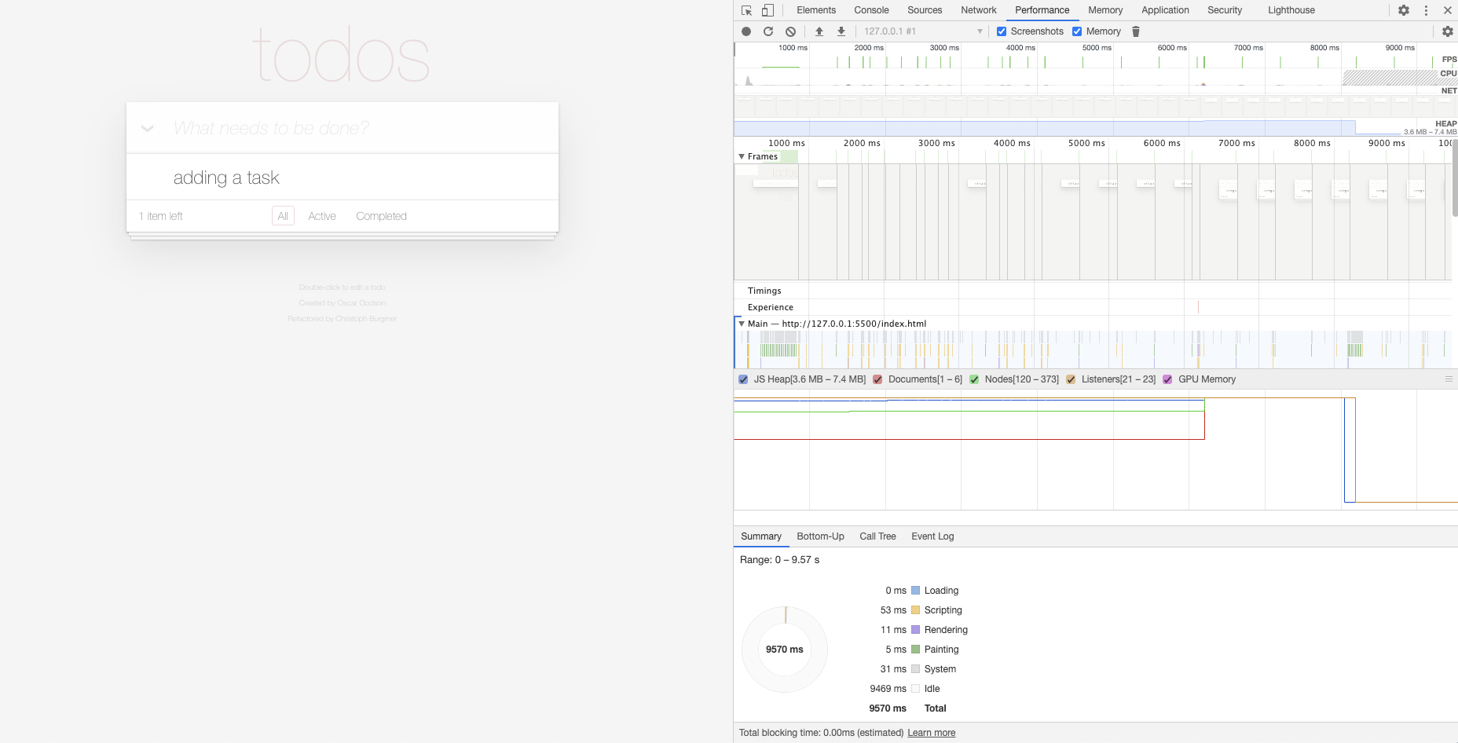

* Making a single task to be completed
  + Scripting - 36 ms
  + Rendering - 15 ms

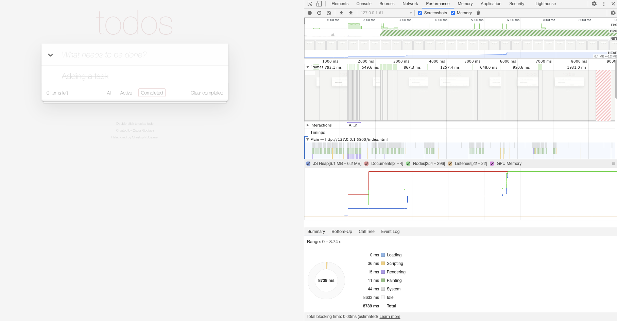

* Marking multiple tasks to be completed
  + Scripting - 37 ms
  + Rendering - 20 ms

Rendering almost triples in load vs a single task marked

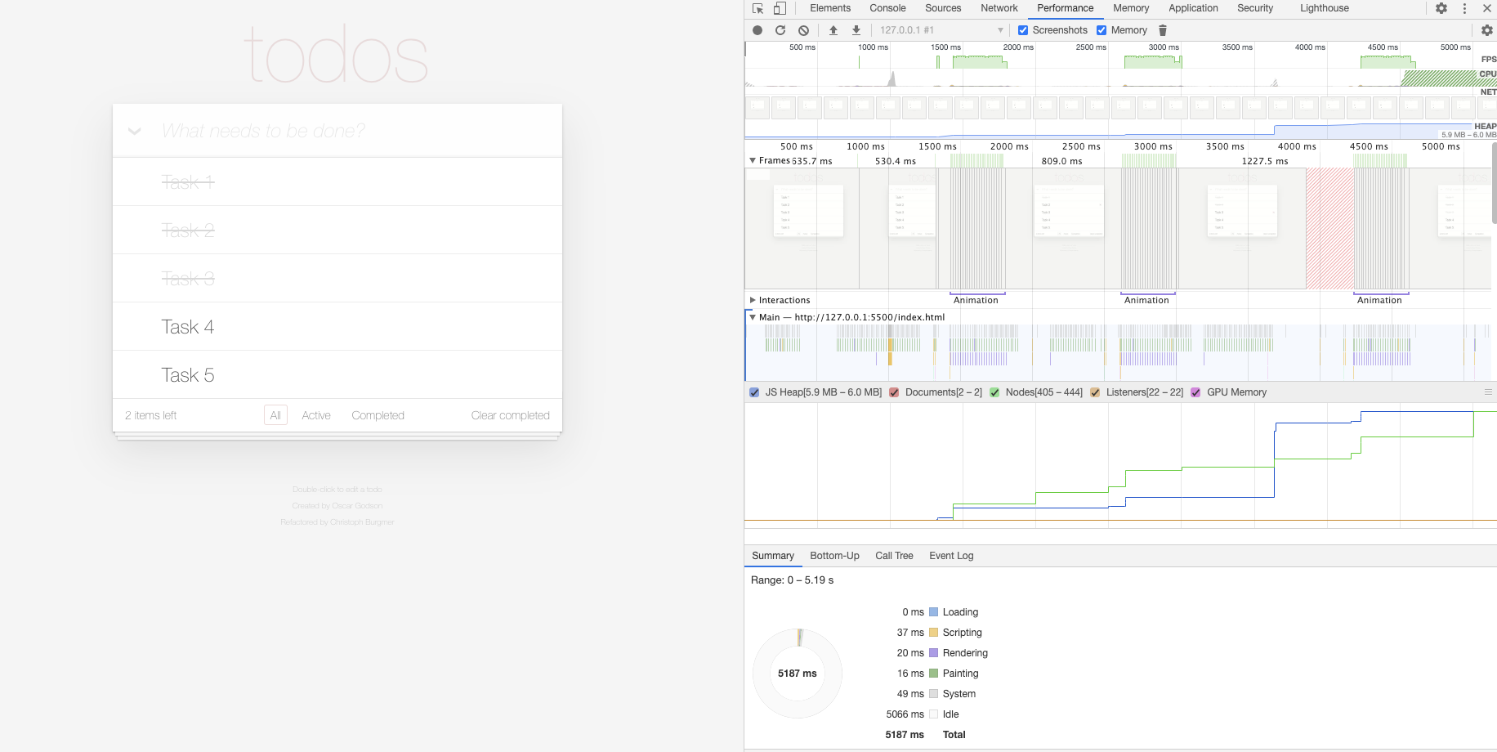

* Clearing multiple completed tasks
  + Scripting - 34 ms
  + Rendering - 7 ms

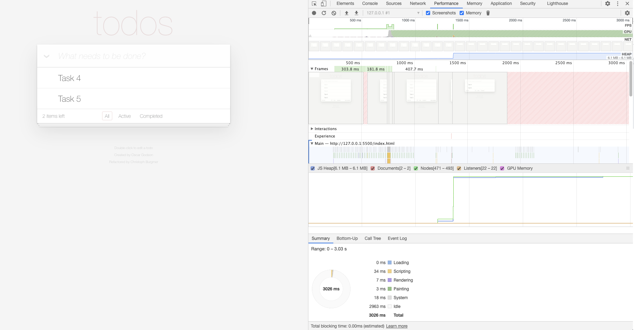

* Navigating all 3 filters in the view
  + Scripting - 40ms
  + Rendering - 21 ms

As expected this is more of a rendering heavy operation so it takes more time.

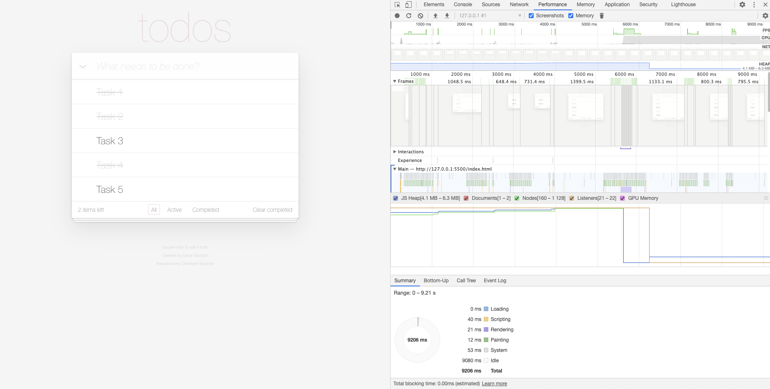

**Competitor’s App Audit**

The tests were done in the same Mac environment as before with the Own App Audit.

Overview of the Competitor App

The competitor app is a richer app that includes different types of features like: several todo lists in parallel, scheduling them to calendar dates, maintaining several lista that can have tasks migrated, the list can be ordered and the results can be printed by simply pressing a button.

In comparison with our App, the user experience and the UX design of it are way more advanced. Simply the drag and drop, modals/dialogs, pop windows functionalities provide a different perspective on its complexity.

The improvement areas of this application would be around the CSS as is noticeable that there are some alignment issues of the todo manager application. You can appreciate that the list

Tests

The App uses a jQuery library, It shows ads on the right side of the page, which loads really slowly especially on the slow 3G network this can be appreciated on the screenshots provided below.

This site provides features that are not provided in our version, that’s why the implementation of the test was applied into similar options to our app so we would compare the behaviour and the results.

The tests showed that the competitor’s App JavaScript implementation is really slow compared to our own app. It takes a considerable amount of time to simply add a todo and mark one as a complete compared to our own app. Results can be found below as well.

* Page load - online network

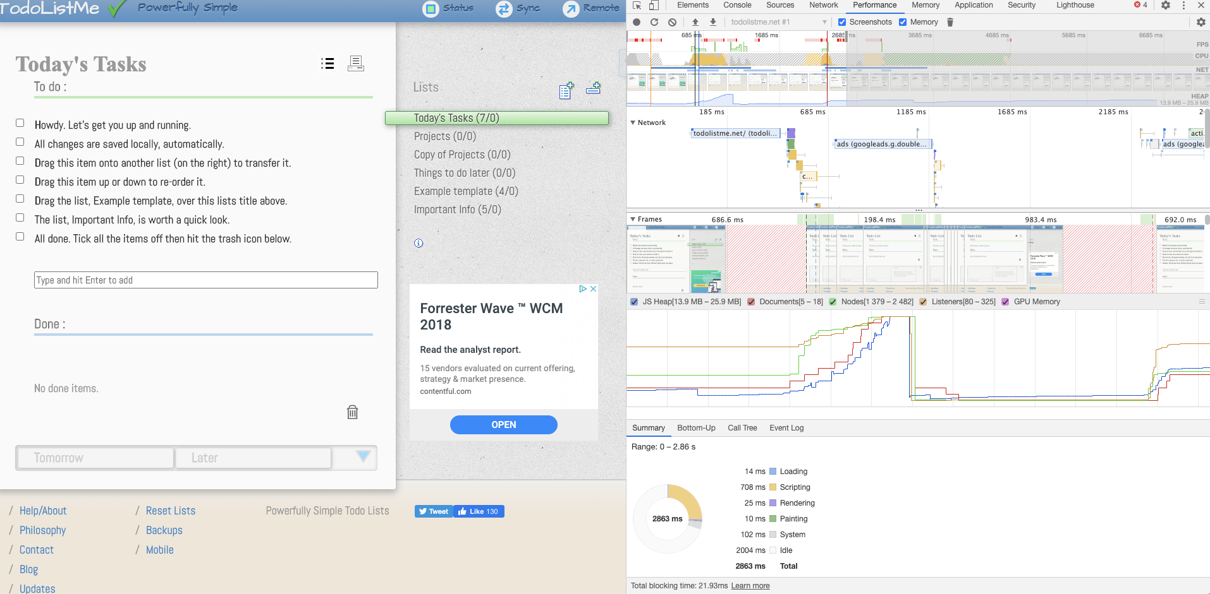

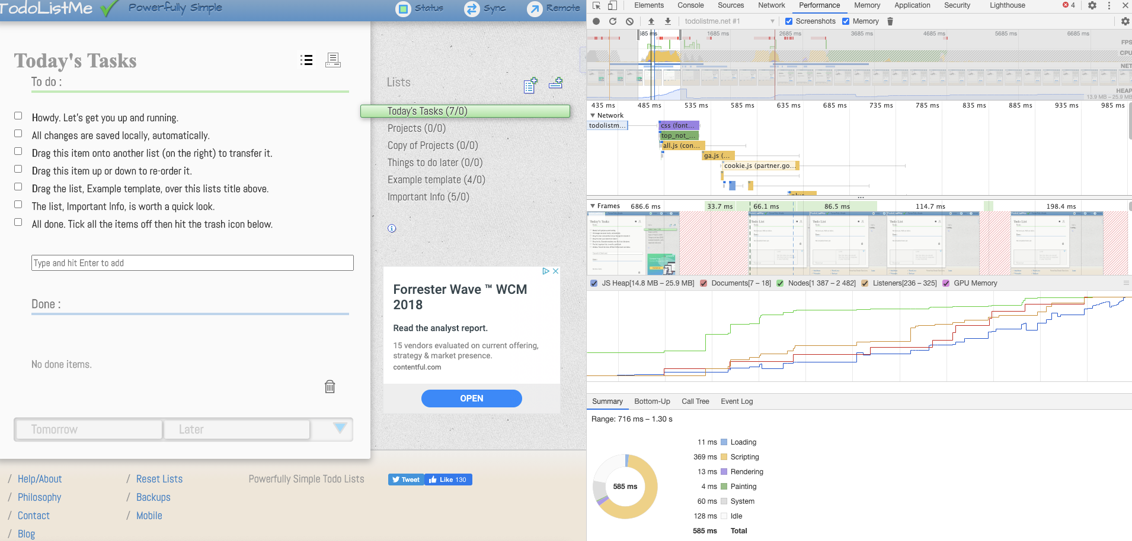

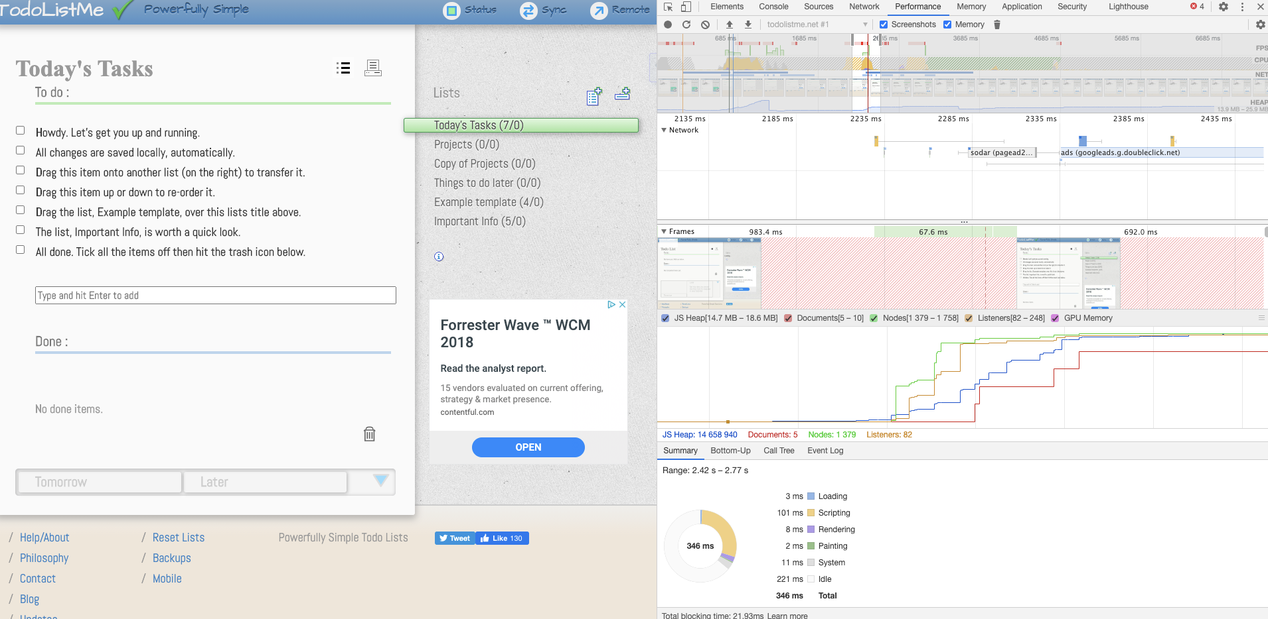

* Network - online
  + DOMContentLoaded - 654 ms

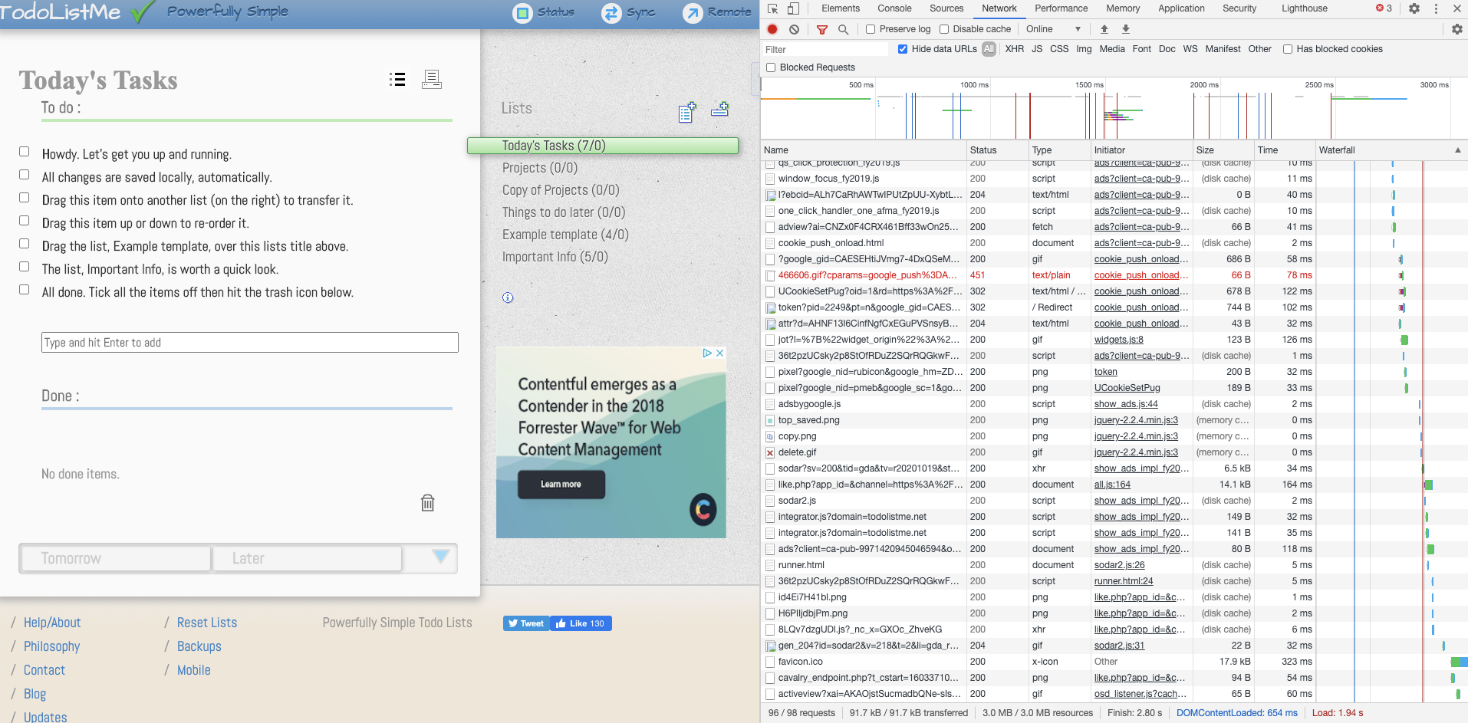

* Network - Slow 3G
  + DOMContentLoaded - 2.36 s

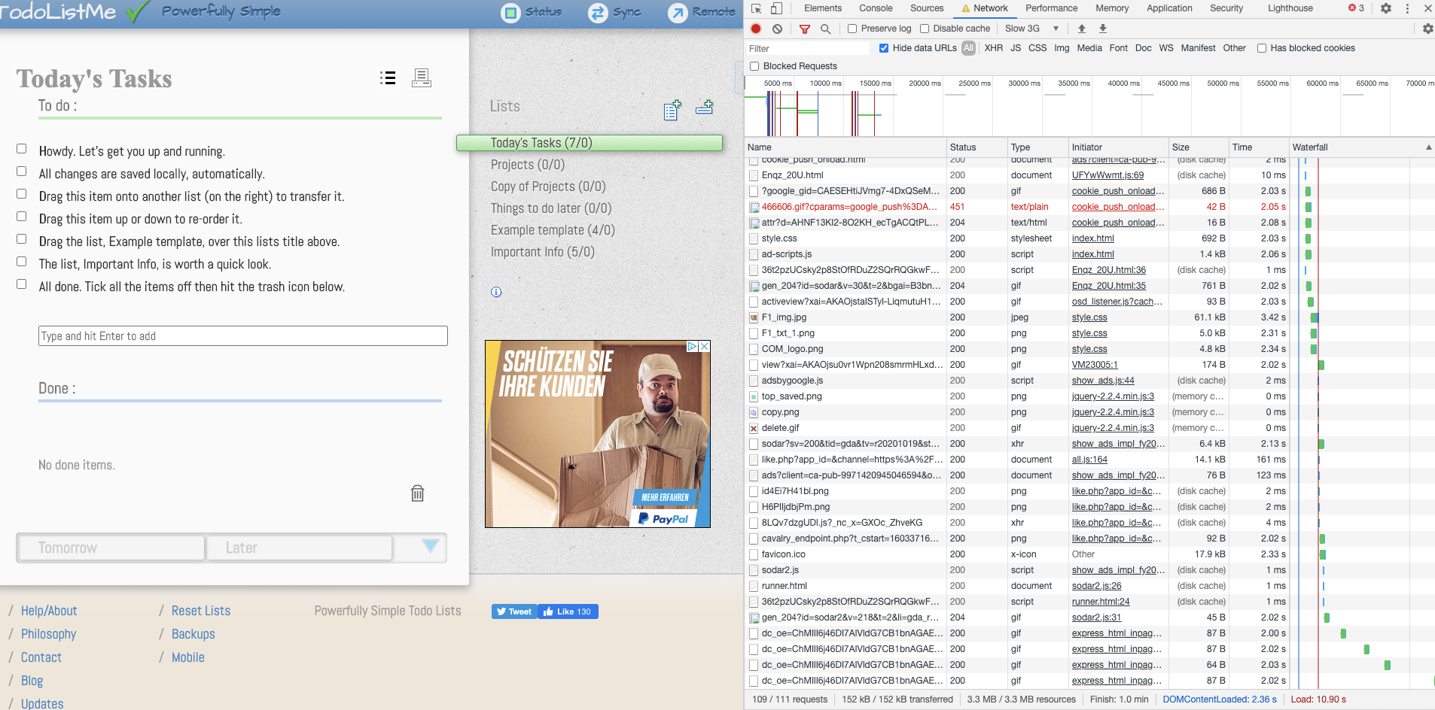

* Memory allocation
  + The app itself requires at least 22MB of reserved memory.

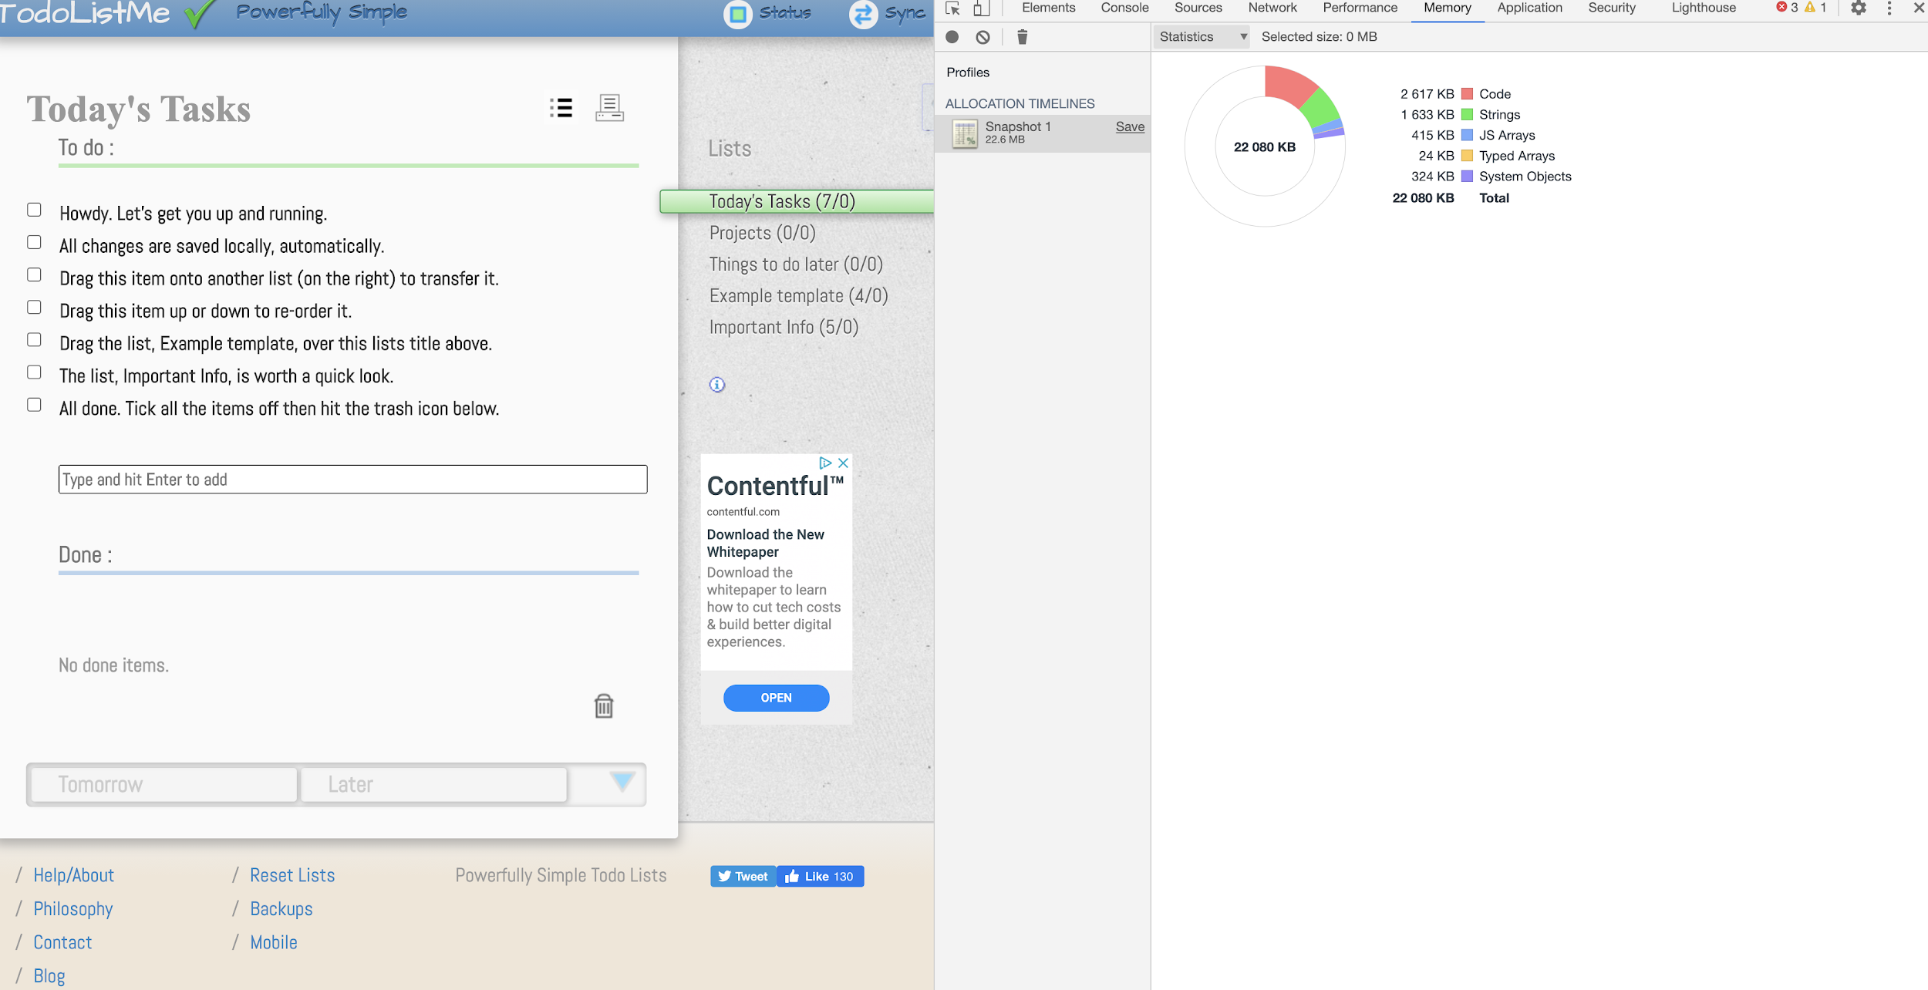

* Adding a todo item in Today’s Tasks list
  + Scripting - 281 ms
  + Rendering - 57 ms

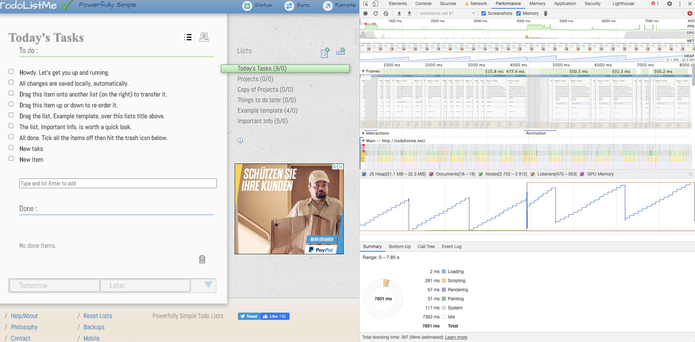

* Adding a todo item in Copy of Projects
  + Scripting - 185
  + Rendering - 42

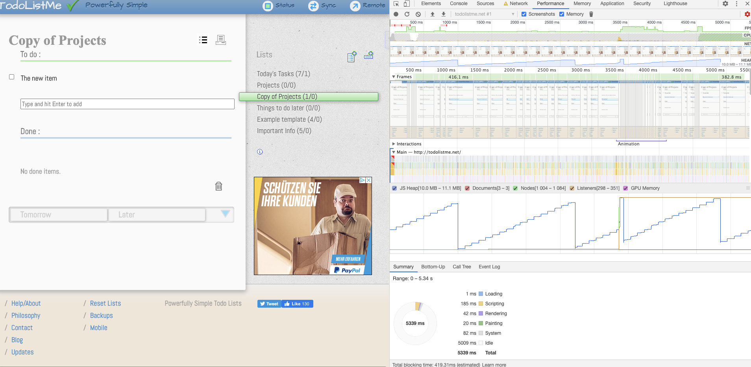

* Adding a todo item in Things to do later list
  + Scripting - 192 ms
  + Rendering - 25 ms

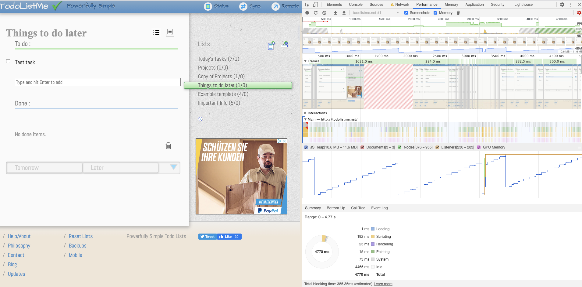

* Marking a todo as completed
  + Scripting - 172 ms
  + Rendering - 73 ms

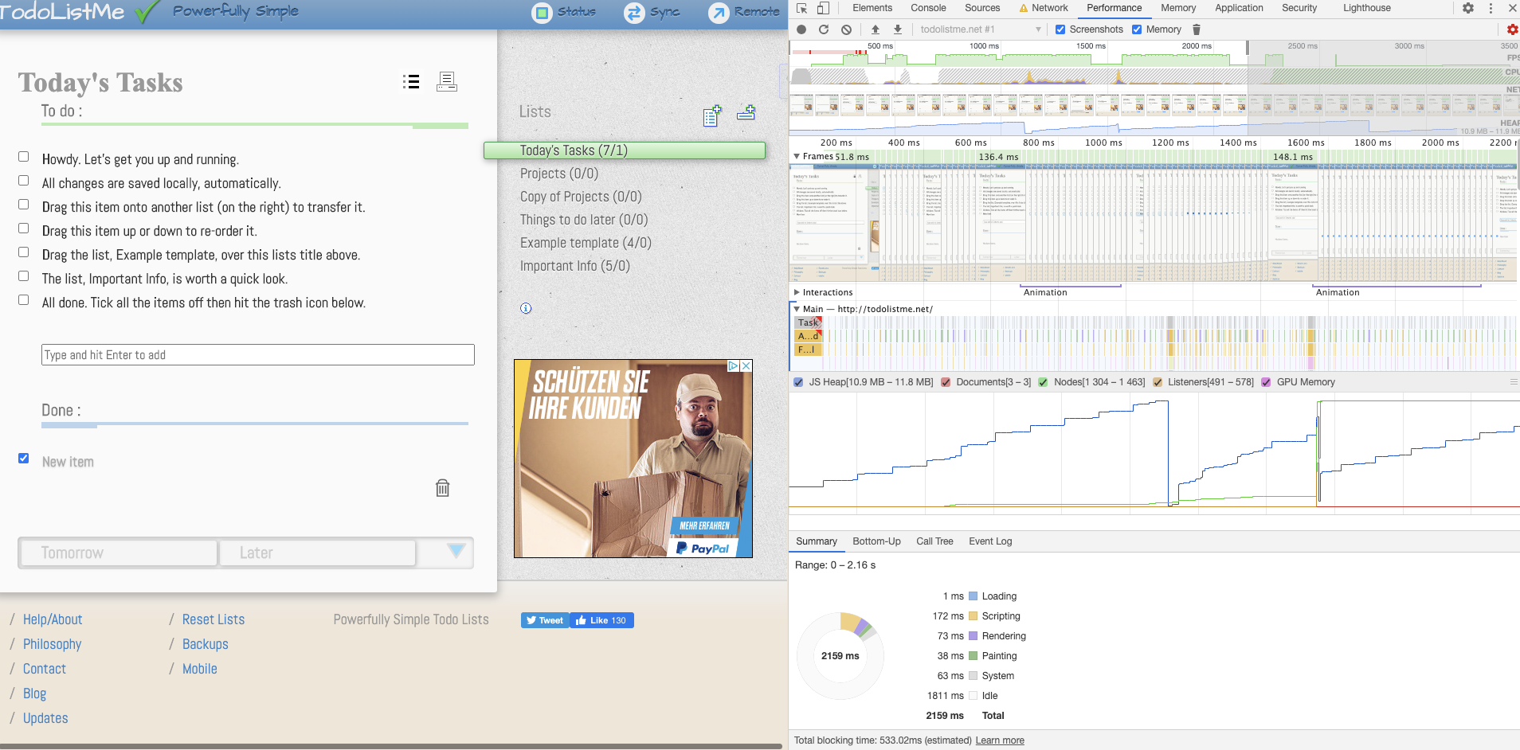

* Select a different filter views
  + Scripting - 281 ms
  + Rendering - 98 ms

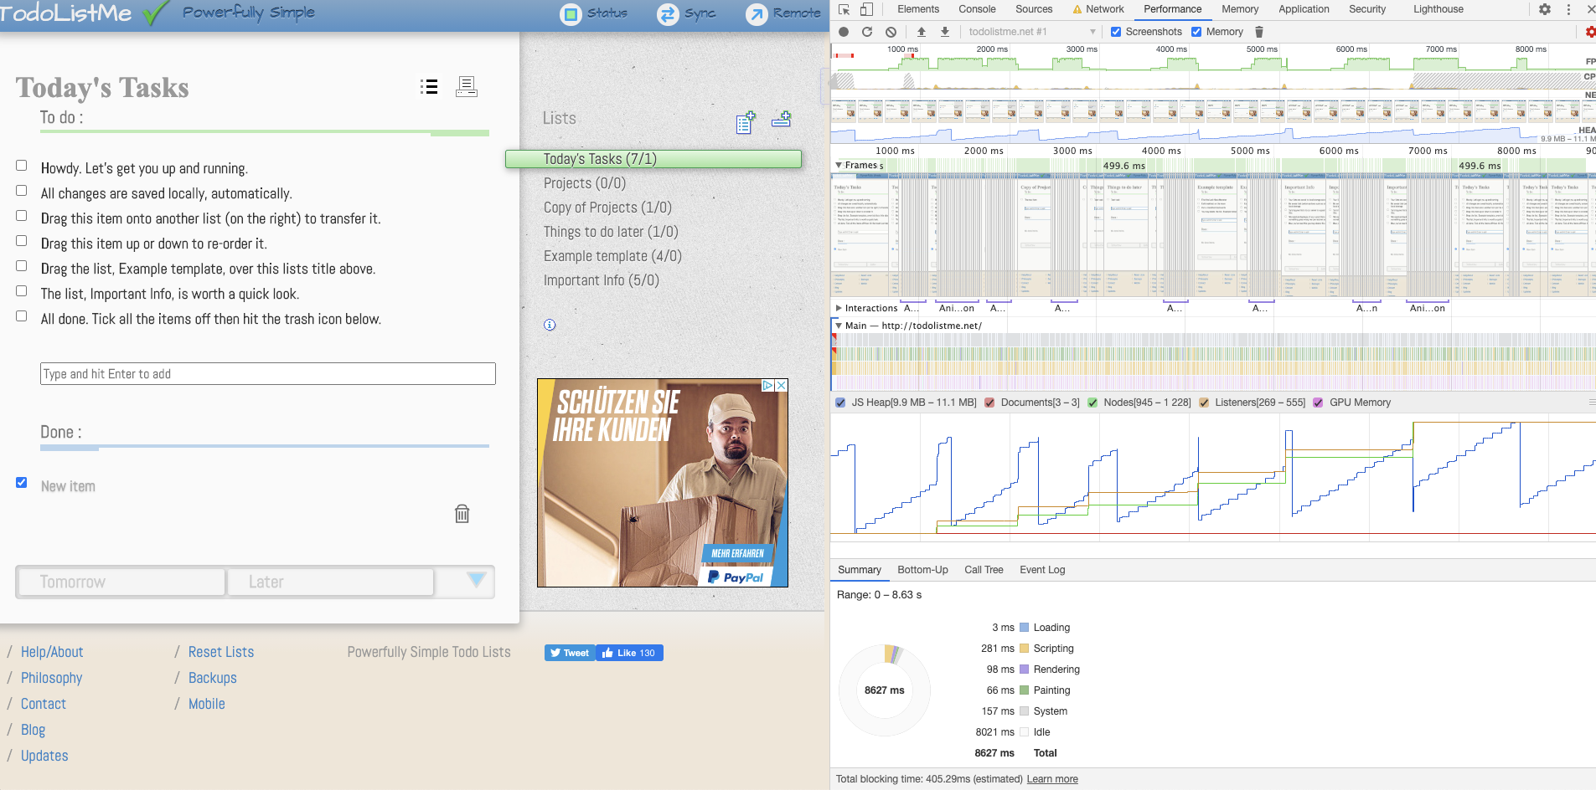

**Overall comparison**

Own App

* App size - 35.7 Kb
* Load time - 9ms
* DOMContentLoaded - 106ms
* Memory allocation- 3.54 MB

Competitor’s App

* App size - 3.9 MB
* Load time - 14 ms
* DOMContentLoaded - 654ms
* Memory allocation- 22.6 MB

As per above results we can observe that our competitor’s app loads significantly slower, allocates more memory, and remains slow and inefficient when adding new todo’s and operating with its lists and their data.

Consideration for our App:

Our app is a simple todo app that is implemented with MVC pattern. This is an overkill for an app that this functionality wise acts like a simple component in a modern framework. While our app is fast, efficient, and using low resources vs our competitor app it can be improved by refactoring the codebase and using MVVM architecture or a least some sense of data binding rather than MVC. It would be preferential if the app could be implemented in a modern front end framework such as React or Vue as it would allow the integration as a component to other applications, even when it means a slight performance drop, and increased memory usage, that is still acceptable even on slow mobiles. Even if the decision is made to stay with pure JavaScript ES6 syntax should be implemented and global var variables changed to let, const to be more efficient with parameters staying true to their scope.